BRONCOS-JAGUARS YOUTH ATHLETIC CLUB LTD.

Mr. Larry (Coach Red) Faulks Mr. Wayne Baxter

Executive Director Norfolk, VA Assistant Executive Director
(757) 383-3227
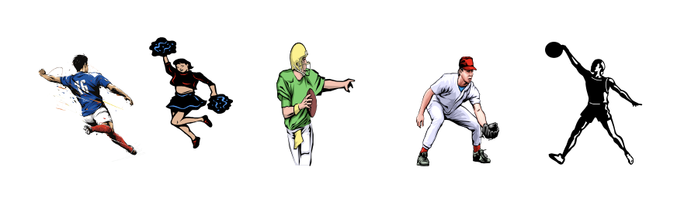
“Kids are our Future”
Registration Contract (Revised August 12, 2024)

2024 - 2025 Sport Season

Child’s Age ________

Child’s Name___________________________________________________________________

Last First Middle

School: ____________________________________________________________

Date of birth: ______________________ male______ female____

Address: ___________________________________________________________

City/State/Zip: ______________________________________________________
Telephone: Day( )___________ Night( )________________________________

Emergency Contacts:

Name________________________________ Relationship___________________

Address: ___________________________________________________________

City/State/Zip: ______________________________________________________

Telephone: Day( )___________ Night( )________________

I hereby give my permission for my child, named above, to participation in the Broncos Jaguars Youth Athletic Club (BJYAC) programs. I understand that I must provide insurance coverage for my child and be responsible for his/her physical. Also, I will save the BJYAC free and harmless from his/her participation. Additionally, I understand that my child’s participation in sports carries the risk of injury. All equipment and uniforms (if) issued to my child by BJYAC shall be return at the request of coaches or directors of BJYAC.

Academic Performance Agreement

At BJYAC, we believe that academic success is just as important as athletic achievement. To ensure that our young athletes maintain a healthy balance between their studies and sports activities, we have implemented the following academic performance policy:

Grade Submission Requirement
Each participant in BJYAC programs is required to submit their academic grades at the end of each semester or grading period as determined by their school.

Submission Process
a. Grades must be submitted within one week of the official grade release date.
b. Acceptable forms of grade submission include official report cards, online grade printouts, or direct communication from the school (with parent or guardian(s) permission).
c. Grades should be submitted to the team coach or designated BJYAC staff member.

Academic Standards
a. To maintain full participation status, athletes must maintain a minimum grade point average of [GPA 2.0] or its equivalent.
b. Athletes must not have any failing grades (F) in core subjects (Math, Science, English, Social Studies).

Consequences of Not Meeting Academic Standards
a. If an athlete's grades fall below the required standards, they will be placed on academic probation for the following grading period.
b. During academic probation, the athlete may have limited participation in practices and games, as determined by BJYAC leadership and the athlete's parent(s) / guardian(s).
c. An athlete on academic probation will be required to attend study sessions or tutoring as arranged by BJYAC or the athlete's family.

Return to Full Participation
Athletes can return to full participation status once they submit grades showing they have met the required academic standards.

Privacy and Confidentiality
All grade information submitted will be kept confidential and will only be used for the purpose of determining eligibility for BJYAC programs.

Support and Resources

BJYAC is committed to supporting our athletes' academic success. We will provide resources and support for athletes who may be struggling academically, including study skill workshops, peer tutoring, or referrals to academic support services.

By signing below, we (athlete and parent/guardian) acknowledge that we have read, understand, and agree to abide by the BJYAC Academic Performance Agreement. We understand that failure to meet these requirements may result in limited participation or suspension from BJYAC activities until academic standards are met.

Warning: Participation in the Broncos- Jaguars Athletic Club's program is voluntary. Participation in sports activities carries a risk. I assume all risk and accept responsibility for any and all injuries that may be incurred while participating in the Program. This includes injuries that might be incurred in travel to and from the club activities. I am aware that participation in Club Sports involves a risk of serious injuries due to contact with individuals playing in the game or contact with the floor, walls, goals, posts or equipment which are part of the playing area. I agree and acknowledge that I am responsible for all losses, liabilities and expenses, which may be incurred or sustained as a result of my child participation in the Program not covered by my insurance policy.

By signing and initialing this document, I consent to the following statements:

1. I hereby give my permission for my child, named above, to participate in the Broncos-Jaguars Youth Athletic Club (BJYAC) programs. ______ initials

2. I understand that my child participation in sports carries the risk of injury. ______ initials

3. I acknowledge that my child may suffer a personal injury, property damage, or other loss due to participating in sports activities. ______ initials

4. I understand that the club and its sponsors, and staff will take all reasonable precautions to ensure the safety of participants but cannot guarantee that accidents or injuries will not occur. ______ initials

5. In the event of an emergency, I do hereby give permission to BJYAC to act in my stead to consent to any medical treatment or hospitalization deemed necessary by a licensed physician or emergency team. I agree to be liable for any or all costs involved in such treatment or hospitalization. _____initials

6. I agree to the BJYAC taking photographs and videos of my child during activities, and I agree that these images may be used for promotional purposes by the Club without any further consent or compensation. ______ initials

7. I understand that Broncos-Jaguars Youth Activity Club (BJYAC) requires that I provide health insurance coverage for my child. ______ initials

8. I attest that my child is physically fit to participate in Broncos-Jaguar Youth Athletic Club sport activities and have no known medical conditions that would prevent or Limit his/her participation. ______ initials

9. I understand that I am responsible for obtaining and submitting a current physical examination. ______ initials

10. All equipment and uniforms (if) issued to my child by BJYAC shall be returned at the request of coaches or directors of BJYAC. ______ initials

Print Name: _____________________________________________________________

Parent(s)/Guardian(s) Signature: ________________________ Date: ___/___/______

Print Name: _____________________________________________________________

BJYAC Representative Signature: ________________________ Date: ___/___/______

Print Name: _____________________________________________________________

